UNEMPLOYMENT INSURANCE, DISABILITY INSURANCE, AND WORKERS’ COMPENSATION

1. General Technical summary

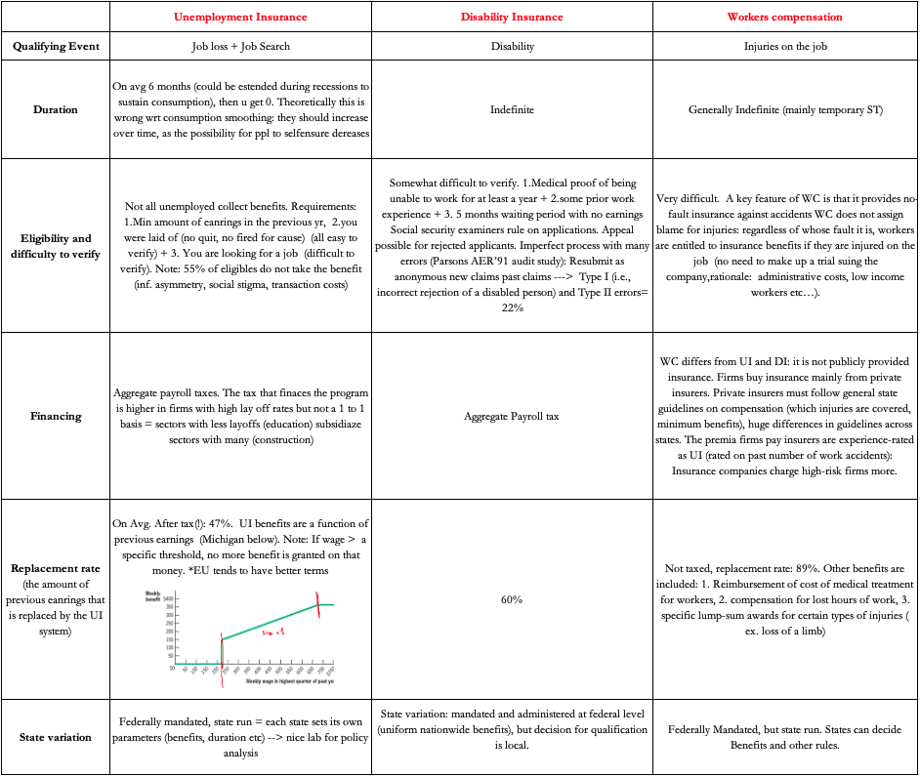

2. Cost benefit analysis
A. UI
a. Costs
Idea: Do unemployment benefits reduce incentive to search for work while unemployed (moral hazard)
I. Simple Time-series evidence
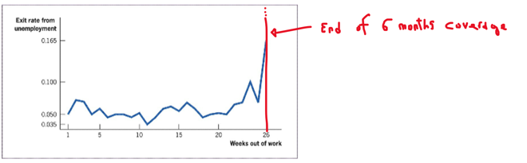
But NOW: how much k% unemployment is created by a +1% benefit?

II. Meyer (1990) Quasi-experiment using state reforms
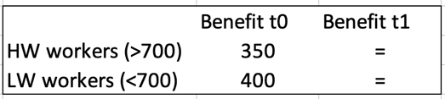
Quasi-Experiments for Studying the Effect of UI Benefits on Unemployment Durations. The treatment state of New Jersey originally provides a maximum benefit of $350 for workers earning more than $700 per week. It then raises its maximum benefit to $400, which applies to all workers earning more than $800 per week (group H). Workers earning less than $700 per week (group L) are not affected by this policy change.
This policy change sets up a natural quasi-experiment: difference in difference! General finding: benefit elasticity of 0.4-0.6 ⇒ 10% rise in unemployment benefits leads to about a 4-6% increase in unemployment durations.
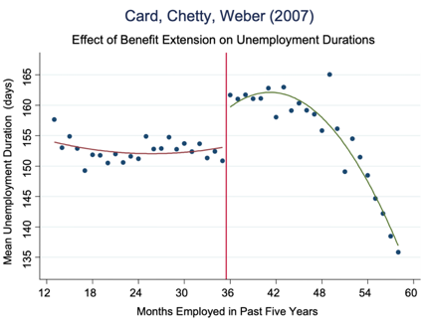
III. Card-Chetty-Weber (2007). The longer you earn the benefits the longer unemployment duration
in Austria, you get up to 30 weeks of benefits when you have been employed for 36+ months in last 5 years (instead of up to 20 week baselines)
Can look at mean unemployment duration (y) wrt on how long you have worked in last 5 years (x) ⇒ Finds elasticity around 0.3

HOWEVER: VI. Does UI have Long-Term Benefits? Longer time = Best matches? NO!
If workers spend this time looking for better jobs, however, longer durations might be an efficient outcome of UI. Taking the first job that they are offered could be inefficient. The best way to do so is to study the quality of the post-UI job matches --> wage rates should be some indication of their quality. A finding that higher UI leads to higher post-unemployment wages would indicate that job matches are better. However, this is false
Card-Chetty-Weber (2007) exploits the regression discontinuity and finds no long-term match benefit on subsequent wage or job duration.

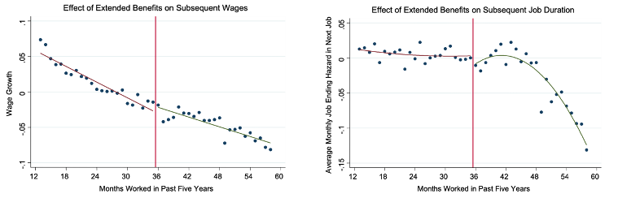
WE JUST CARE ABOUT THE OBSERVATIONS AROUND THE CUTOFF --> NO DIFFERENCE IN WAGE GROWTH / JOB ENDING HAZARD
* Problem: For high skill jobs maybe the time reasoning could be understandable
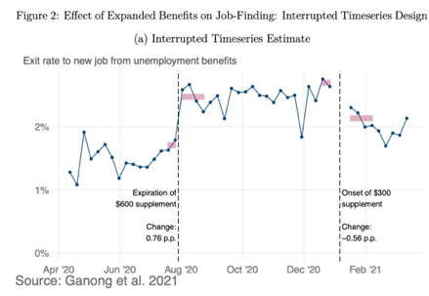
V. Ganong et al. (2021). Just time-series analysis
analyze the impact of the huge UI expansion during the COVID-19 pandemic.
They find that the weekly exit rate from UI to new job:
(a) Jumps up from 1.8% to 2.6% when $600 (weekly) supplement (to basic normal benefit you should earn) ends
(b) Jumps down from 2.6% to 2.0% when $300 suppl. starts
⇒ moral hazard cost present but low! = UI was an efficient way to help job losers during the pandemic!

b. Benefits
Idea: Helps people in a time of need (consumption smoothing) + Macro standpoint: it provides support to economy in times of recession: if they are laid off they stop consuming very bad during recession
Evidence:
I. Gruber (1997): individuals are not fully insured by other sources against the income loss of unemployment
--> that their consumption falls significantly when they lose their jobs (-22%).
--> and that higher levels of UI do lessen the negative effects of this fall (-7%)
However, the role of UI in consumption smoothing is limited: for each dollar of UI, $0.30 goes to increase consumption, and $0.70 crowds out self-insurance.
II. Ganong-Noel AER’19: uses bank account data to follow people through UI spells.
Finds big effects of UI benefit exhaustion on consumption, especially for groups with high replacement rates or low wealth (obv.). Drop is spending is much smaller than drop in income (see y axis). However there is a myopic behavior, the spend less month by month, do not smooth. To some extent they self-ensure, but not perfectly.

c. Summary of Empirical Findings on UI
1) Higher benefit level implies longer unemployment durations (moral hazard cost).
2) UI benefits have no beneficial effects on long-term job outcomes.
3) Higher benefit level implies more consumption while unemployed (consumption smoothing benefit).
⇒ This implies that providing some UI is desirable, but the UI replacement rate should be below 100%.
Moral hazard cost during deep recessions (such as COVID) seems smaller + huge consumption effect. ⇒ It makes sense to make UI more generous in recessions.

B. DI
Very impressive surge in the last yrs. Growth particularly strong during recessions: early 1990s, late 2000s. Are DI benefits creating unemployment?
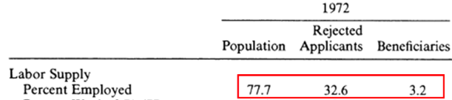
a. Bound AER’89
Analyze those who have been rejected. Use data on work behavior of rejected DI applicants as a counterfactual.
Idea: If rejected applicants do not work, then surely DI recipients would not have worked ⇒ Rejected applicants’ work behavior is an upper bound for the labor force participation rate of DI recipients absent DI. Results: Only 30% of rejected applicants return to work and they earn less than half of the mean non-DI wage.

If accepted P(employment) – 30%

b. Maestas-Mullen-Strand AER’13
We would like to do a regression on unemployment (y) over Disability benefits (x)
problem: omitted variable bias. Higher level of disability both increases unemployment probability and disability benefit
---> can’t use disability benefit as regressor, as it is correlated with the omitted variable --> use examiners stringency as IV
Why is examiners stringency a good IV?
Idea: (a) Random assignment of DI applicants to examiners (validity) and (b) examiners vary in the fraction of cases they reject.
it is valid as it is not correlated with any observed characteristics and relevant as they affect the employment outcome
Adding controls to isolate effects of IV (take residuals of the regression between IV and controls) ---> the distribution changes!!! residualized initial allowance rate
Now:
1. effect of IV on x + 10% residualized initial allowance rate ---> + 2.3% probability of receiving benefit
2. effect of IV on x + 10% residualized initial allowance rate ---> + 0.64% probability of being unemployed
Wrap up: +2.3% benefit --> + 0.64% unemployment
If you have a +2.3% probability of having the benefit you have a +0.64% unemployment
---> those who have a 100% probability of having the benefit will have a ---> 100/2.3 * 0.64 = 28% probability of being unemployed (compared to those in the sample that do not receive DI benefits) --> If accepted P(employment)= – 30% (Consistent with Bound AER’89)
Key; This estimates the causal effects of DI on working behavior for marginal cases: applicants who are admitted by a lenient judge but rejected by a tough judge
Basically: the discrepancies in allowance rates make the difference not for the clear cut cases (super serious disabilities) but for cases in a grey area that a lenient judge consider disability, a severe judge does not --> the average effect on all DI recipients likely smaller: The impact of DI on the ability or decision to work is likely more pronounced in marginal cases, who are closer to being able to work. For those with more severe impairments (non-marginal cases),).

3. Workers compensation
B. The big problem: Moral Hazard
Moral hazard in WC can manifest itself in reported injuries, injury durations, and types of injuries reported (Back pain is very hard to verify).
Evidence:
a. Exploit the timing of injuries, “Monday effect”: magically most of the injuries are on Monday
b. Examine the effect of WC benefit levels on WC durations using a difference-in-differences strategy (Meyer, Viscusi, Durbin 1995).
Some reforms in increased benefits for high-earning workers (but not low-earning workers) in the late 1980s.
Result: 10% increase in WC benefit raises out-of-work duration due to injury by 4%
Problem: we must weigh this against the benefits to reach policy conclusions.
WC gives people more time to heal after injury without rushing them back to work and leads to higher consumption while out of work.
No clean empirical evidence yet on these issues.

